# ****Lab Steps****

## ****Task 1: Sign in to AWS Management Console****

1. On the AWS sign-in page,**Enter IAM Username and Password** in AWS Console and click on the **Sign in** button.
2. Once Signed In to the AWS Management Console, Make the default AWS Region as **US East (N. Virginia) us-east-1.**

## ****Task 2:** **Provision Default VPC****

1. Navigate to **VPC** by clicking on the **Services** menu in the top, then click on **VPC**orOpen the Amazon VPC console via [https://console.aws.amazon.com/vpc/.](https://console.aws.amazon.com/vpc/)
2. Delete the **default VPC** byfollowing the**below steps:**
   * In the navigation pane, choose **Your VPCs.**
   * Select the**VPC**with value as**yes**in**default VPC column.**

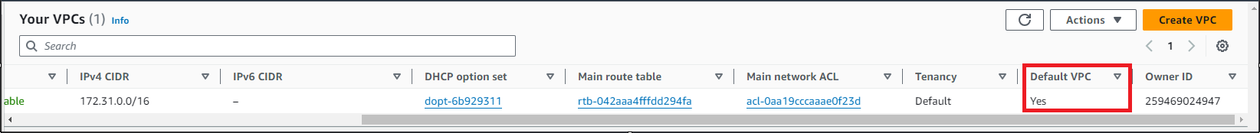

* + Go to **actions button** and click on **delete VPC button**

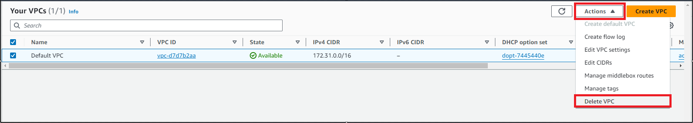

* + Check **I acknowledge that I want to delete my default VPC** option.
  + Type **delete default VPC**and click on **Delete button**

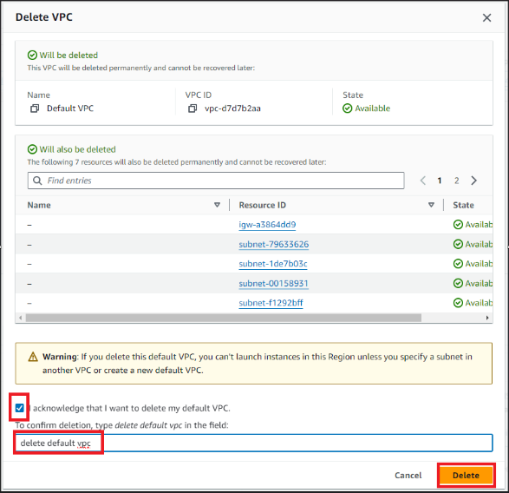

1. Now to provision **Default VPC**again
   * Refresh your console go to **actions**and click**Create default VPC**

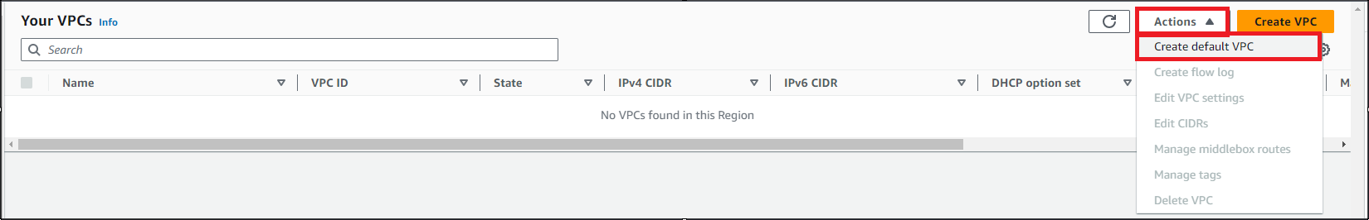

* + Click**Create default VPC button**and your default VPC will get created

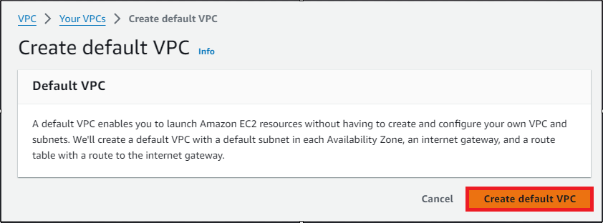  
  
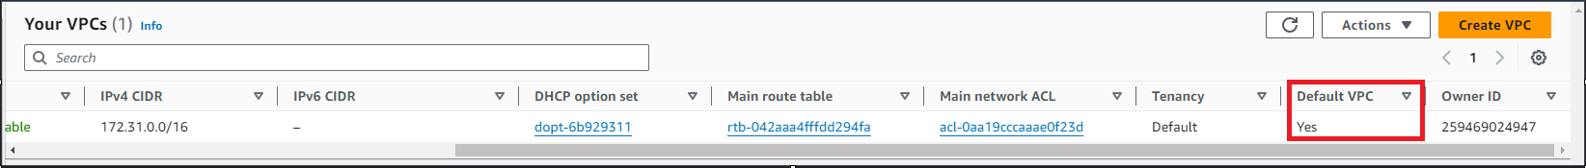

## ****Task 3 : Launch an EC2 Instance with desired specifications****

1. Ensure you are in the **US East (N. Virginia) us-east-1** Region to begin launching an EC2 instance in the Amazon cloud.
2. Navigate to **EC2** by clicking on the **Services** menu in the top, then click on **EC2** in the **Compute** section.
3. Click on the **Instances** option on the left panel, and then click on the **Launch Instances**button.
4. Name : Enter **MyEC2Server**

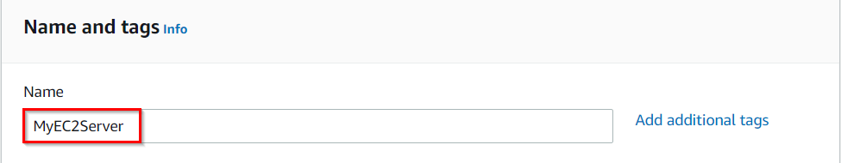

1. Search for **Amazon Linux 2 AMI** in the search box and select it by clicking on the **Select** button.

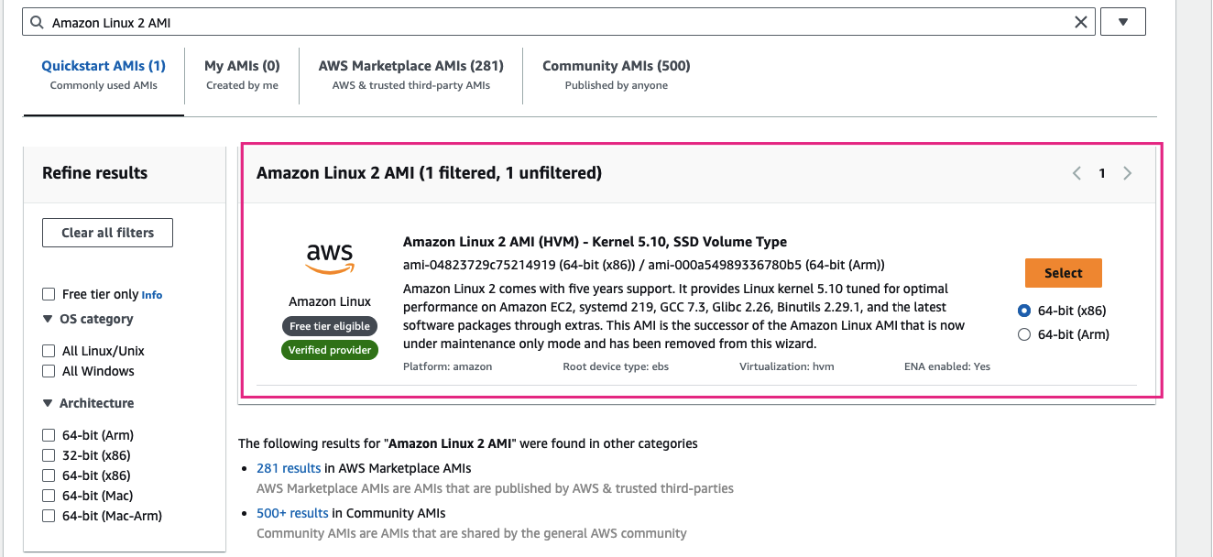

1. **Note:** if there are two AMI's present for Amazon Linux 2 AMI, choose any of them.
2. An instance type in AWS refers to a virtual server configuration that determines the computing resources, such as CPU, memory, and storage, available to an instance. It is the basic building block for creating an EC2 instance in the AWS cloud.
   * For **Instance Type**: Select **t2.micro**

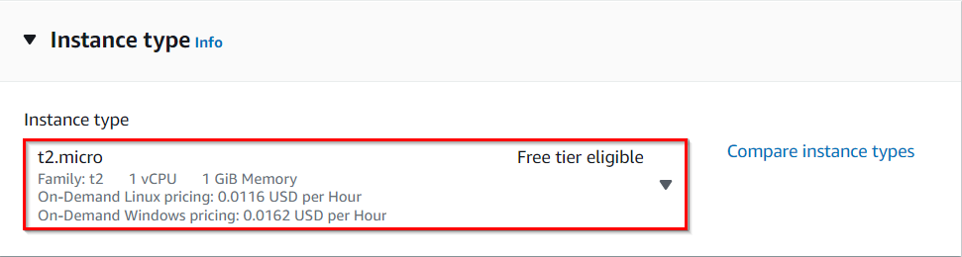

* t2.micro is an instance type in AWS that comes with 1 vCPU, and 1GB memory and is suitable for low-traffic web servers, small development environments, and other lightweight applications.

1. AWS key pair is a secure pair of keys used for login and access to EC2 instances. It includes a public key placed on the instance and a private key kept on the user's local computer, used for authentication to prevent unauthorized access.
   * For **Key pair(login)**: Select **Create a new key pair**Button
     + Key pair name: **MyEC2InstanceKey**
     + Key pair type:**RSA**
     + Private key file format: **.pem**
2. In **Network Settings** Click on **Edit** Button:
   * Auto-assign public IP: **Enable**
   * Select **Create security group**
   * Security group name: Enter **MyEC2Server_SG**
   * Description: Enter **Security Group to allow traffic to EC2**

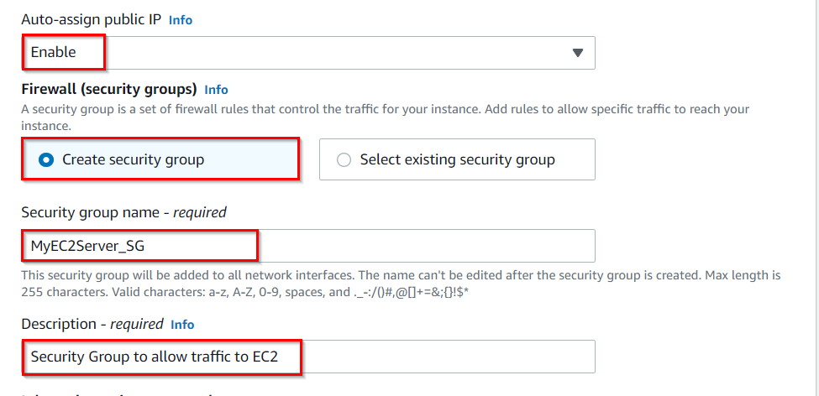

* We will now add the security group rules. SSH will already be present there.
  + For HTTP, Select **Add security group rule**Button
  + Choose Type: Select **HTTP**
  + Source: Select **Anywhere**



1. A security group is a virtual firewall that controls the inbound and outbound traffic for instances in a particular network in a cloud computing environment. Here we have selected SSH and HTTP rules that will allow incoming SSH and HTTP traffic to instances that are associated with the security group.
2. Proceed with launching the instance while leaving all other settings as default. Simply click on the **Launch Instance**without modifying any other configuration.
3. To view the instance that you have created, choose the **View all Instances** option.
4. Launch Status: Once you have initiated the instance launch process, Go to the Instances page from the left menu and wait for your EC2 instance to become "**Running**" while ensuring the health check status is **2/2 checks passed**for optimal performance.

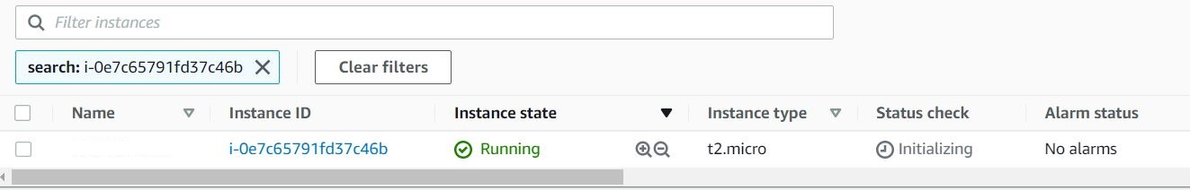

1. **Select** the instance that you have created and**copy** the public IPv4 address within the details section and **paste** it into the editor for later use. An example of this process is depicted in the screenshot provided.

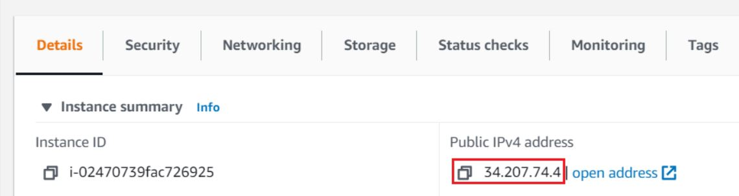

## ****Task 4 : SSH into EC2 Instance using the key pair****

1. Select your EC2 instance(**MyEC2Server**) and click on the **Connect**button.

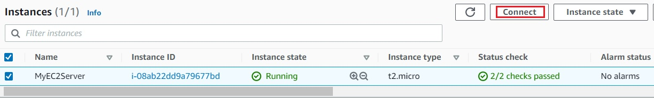

1. Select **EC2 Instance Connect**option and click on **Connect**button.(Keep everything else as default)
2. A new tab will open in the browser where you can execute the Linux Commands.
3. Please follow the steps in [SSH into EC2 Instance](https://www.whizlabs.com/labs/support-document/ssh-into-ec-instance) for more options to SSH.

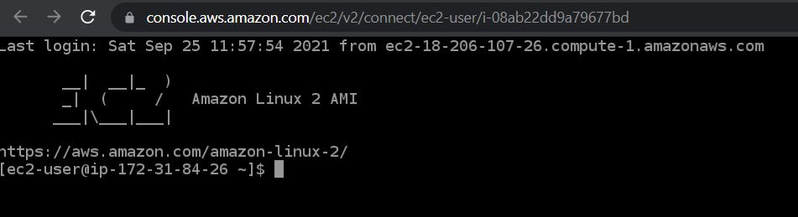

## ****Task 5: Install an Apache Server on the instance****

In this task, our goal is to configure an Amazon EC2 instance to run an Apache Web Server and verify its functionality by accessing the web server via a web browser using the instance's public IPv4 address.

1. Switch to root user:

sudo su

1. Now run the updates using the following command:

yum -y update

1. Once completed, lets install and run an apache server
   * Install the Apache web server:

yum install httpd -y

* + Start the web server:

systemctl start httpd

* + Now Enable httpd:

systemctl enable httpd

* + Check the webserver status

systemctl status httpd

* + You can see Active status is running.
  + You can test that your web server is properly installed and started by entering the **public IPv4 address** of your **EC2 instance** in the address bar of a web browser. If your web server is running, then you see the Apache test page. If you don't see the Apache test page, then verify whether you followed the above steps properly and check your inbound rules for the security group that you created.

## ****Task 6: Create a web page and publish it on the instance****

In this task, you will add content to the index.html file using the "echo" command and restart the webserver. Then, you can view the content by entering the public IPv4 address followed by "/index.html" in a web browser, ensuring that the URL protocol is HTTP.

1. To add the contents into index.html file using echo, copy and paste the below command to shell.

echo "<html>Hello, I am a public page</html>" > /var/www/html/index.html

1. Restart the webserver by using the following command:

systemctl restart httpd

1. Now enter the file name,**/index.html** after the **public IPv4 Address** which you got when you created the ec2 instance in the browser, and you can see your HTML content.
   * Make sure **URL Protocol** is **http** not https.
   * Syntax: **http://<Your_Public_IPv4_Address>/index.html**
   * Sample URL: **http://54.152.121.169/index.html**
   * **Note:** If the index.html page is not loading, try removing **s** from the link, it should be HTTP.

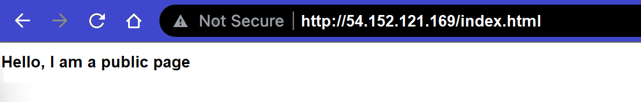

1. If you can see the above text in the browser, then you have successfully completed the lab.

### ****Do You Know?****

The **Amazon EC2 P4d instance** is the most powerful EC2 instance type available, with eight NVIDIA A100 Tensor Core GPUs, 1.1 TB of NVMe storage, and 400 Gbps network bandwidth, making it ideal for large-scale machine learning and HPC workloads.